1. Commands:
   1. docker container run hello-world
      1. docker container run -p <host-port>:<container-port> hello-world
      2. -d: To detach the console.
   2. docker image pull <repo>/<image-name>
   3. docker container ls 🡺 Listing running containers.
      1. docker ps: this is old way.
      2. docker image ls: To list only stopped
         1. -a: To list all (stopped and running)
   4. docker-machine ip
   5. docker container stop <container-id>
   6. docker container start <container-id>: To start stopped container and will run in background.
   7. docker container rm <container-id>
   8. docker container prune 🡺 To remove all stopped containers.
   9. docker container logs <container-id>
      1. -f
   10. docker container exec -it <container-id> bash
   11. docker container commit <container-id>
       1. docker container commit <container-id>
   12. apt-get update
       1. apt-cache search jdk
       2. apt-get install -y <package-name>
   13. Helping Commands
       1. docker --help
       2. docker container --help
       3. docker image --help
2. docker image build -t <image-name> .
3. 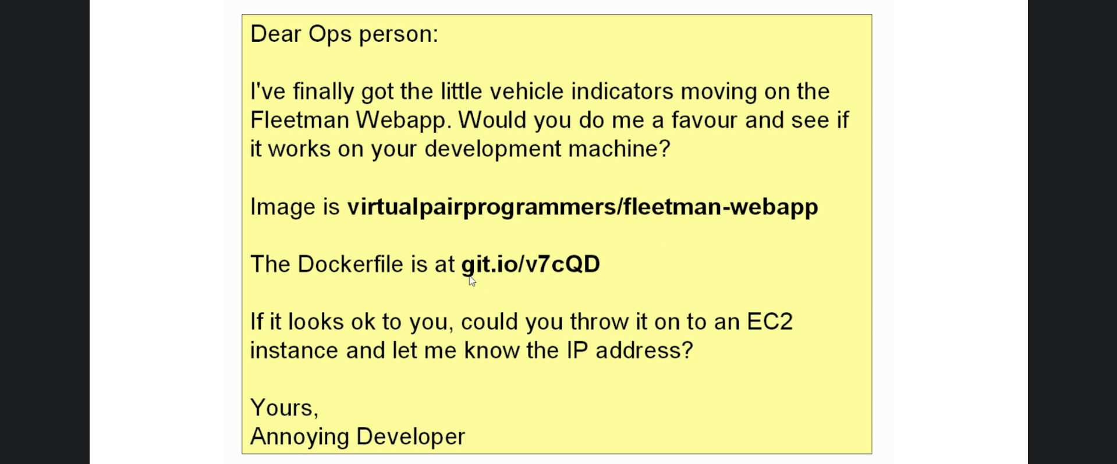  
   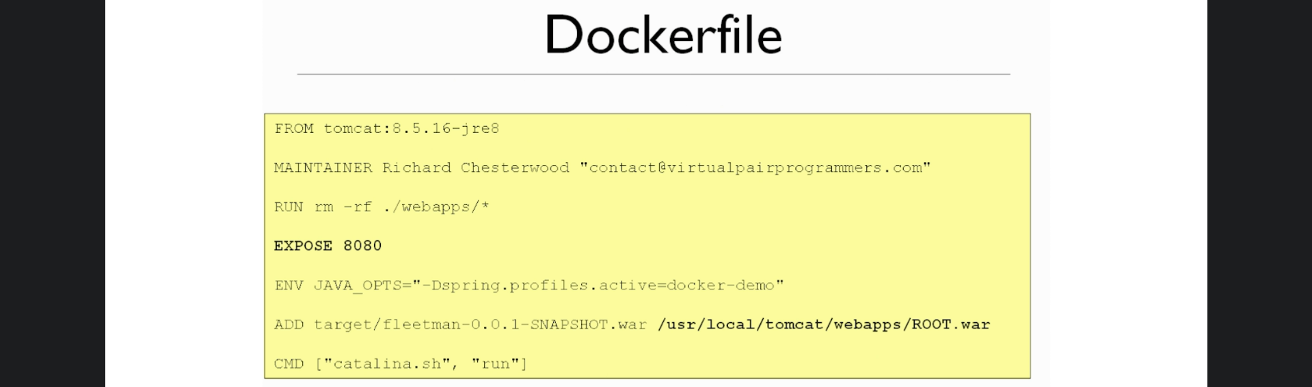
4. 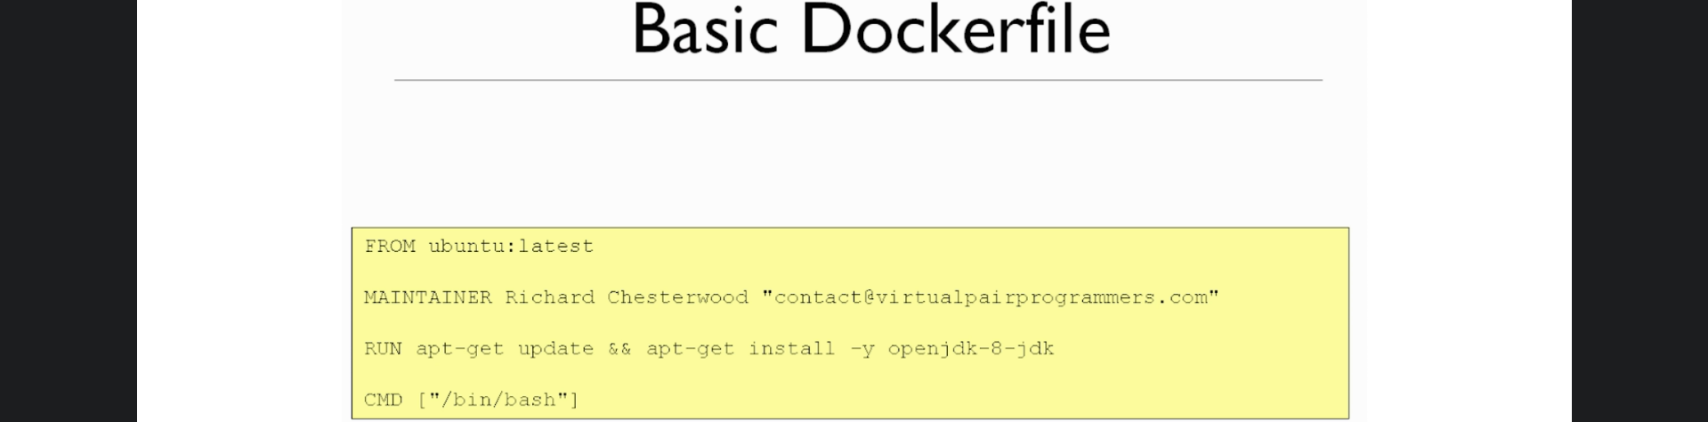
5. 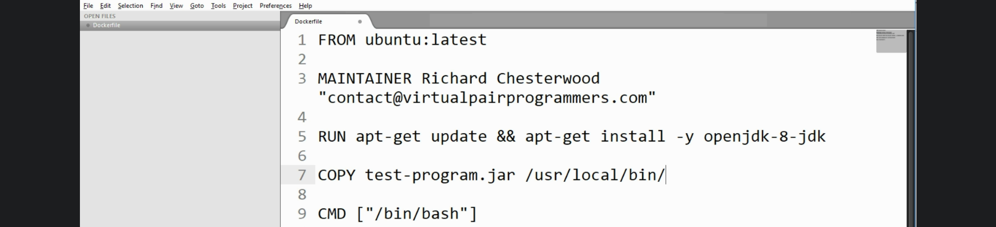
6. 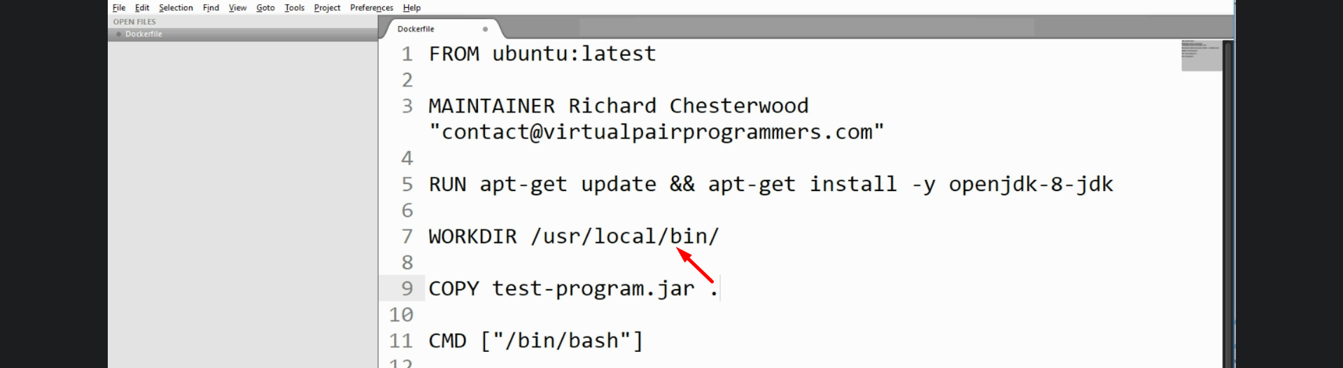
7. 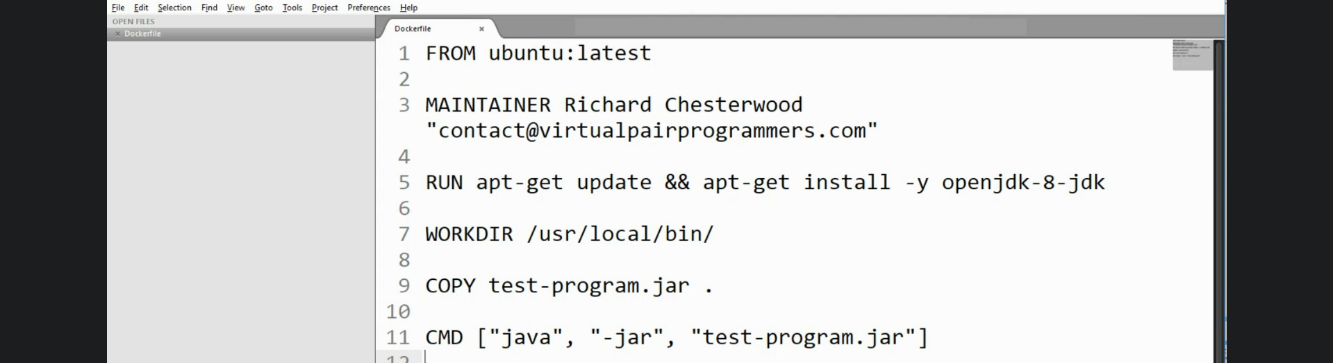
8. COPY vs. ADD
   1. **COPY**: Simple command just to copy.
   2. **ADD**: Same as COPY + Unzipping/unpacking a file and from remote URL.
9. CMD vs. ENTRYPOINT
   1. CMD: Default command and can be overridden.
   2. ENTRYPOINT: Can’t be overridden.
10. LABEL vs MAINTAINER
    1. <https://medium.com/@chamilad/lets-make-your-docker-image-better-than-90-of-existing-ones-8b1e5de950d>
11. 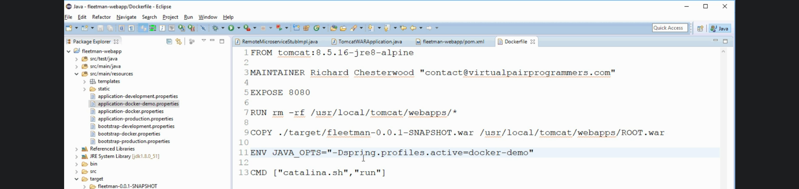
12. docker image tag <image-name> <repository-name>/<imagename>:<tag-name>
13. docker login
14. docker image push <repo-name>/<image-name>:<tag-name>
15. 
16. Container can have more than one name along with id.
17. docker network ls
18. docker network create <network-name>